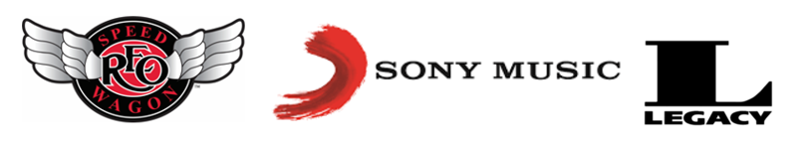

**REO SPEEDWAGON *HI INFIDELITY***

**RIAA DIAMOND AWARD PRESENTATION PHOTOS**

On Thursday, August 17, [**REO Speedwagon**](http://www.speedwagon.com/) received a **Recording Industry Association of America® RIAA 10X** Diamond Award for the band’s landmark album, *Hi Infidelity,* surpassing 10 million units in the United States (one of only 115 albums [approximately] to ever reach that status). At a presentation on Sony Music’s NYC rooftop, REO Speedwagon accepted the award from SiriusXM’s Mark Goodman, along with RIAA, Legacy Recordings and Sony Music executives.

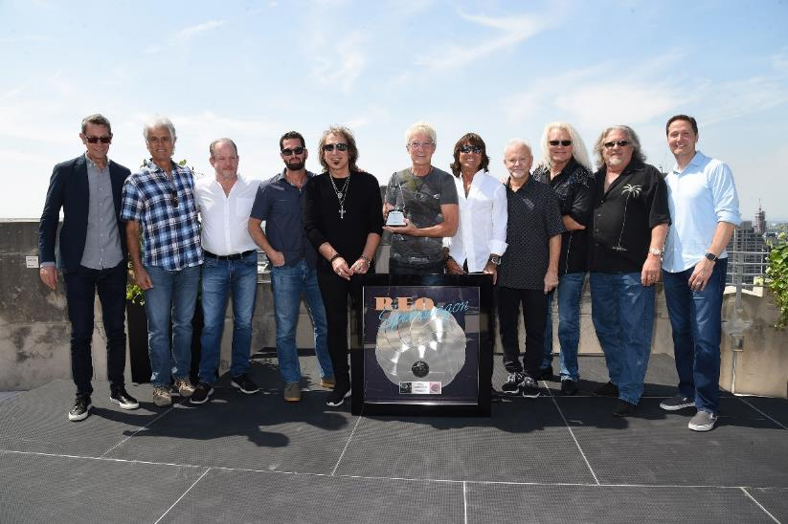

Pictured (left to right): Richard Story (President of CMG - Commercial Music Group), Tom Consolo (REO Speedwagon’s manager), Scott Van Horn (Senior Vice President of Sales, Legacy Recordings), Adam Block (President of Legacy Recordings, a division of Sony Music), Dave Amato (REO Speedwagon), Kevin Cronin (REO Speedwagon), Bryan Hitt (REO Speedwagon), Neal Doughty (REO Speedwagon), Bruce Hall (REO Speedwagon), & Kevin Beamish (co-producer, *Hi Infidelity*) Mitch Glazier (President, RIAA).

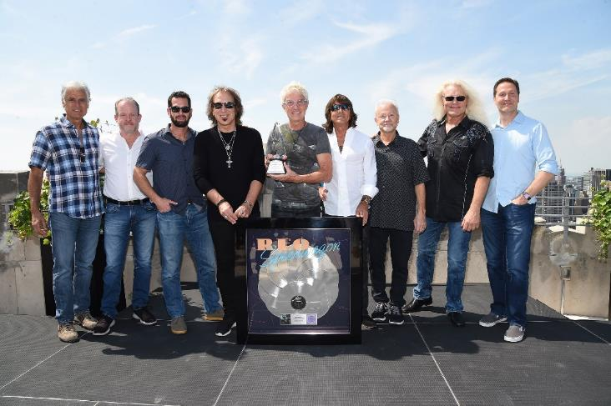

Pictured (left to right): Tom Consolo (manager, REO Speedwagon), Scott Van Horn (Senior Vice President of Sales, Sony Music Entertainment), Adam Block (President of Legacy Recordings), Dave Amato (REO Speedwagon), Kevin Cronin (REO Speedwagon), Bryan Hitt (REO Speedwagon), Neal Doughty (REO Speedwagon), Bruce Hall (REO Speedwagon) & Mitch Glazier (President, RIAA).

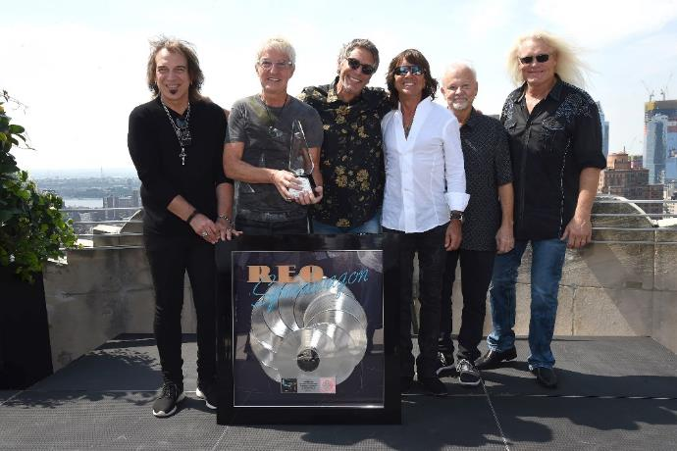

Pictured (left to right): Dave Amato (REO Speedwagon), Kevin Cronin (REO Speedwagon), Mark Goodman (SiriusXM), Bryan Hitt (REO Speedwagon), Neal Doughty (REO Speedwagon) & Bruce Hall (REO Speedwagon).

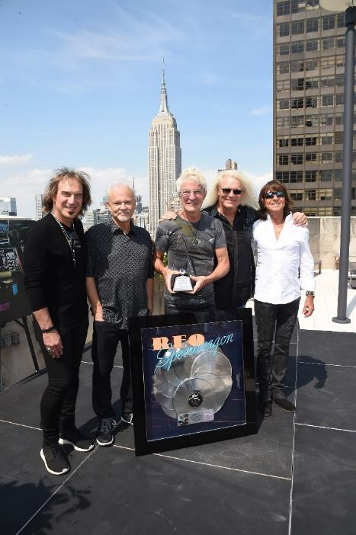

Pictured (left to right): REO Speedwagon’s Dave Amato, Neal Doughty, Kevin Cronin, Bruce Hall & Bryan Hitt.

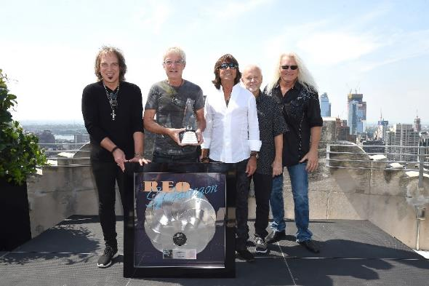

Pictured (left to right): REO Speedwagon’s Dave Amato, Kevin Cronin, Bryan Hitt, Neal Doughty & Bruce Hall.

**For high-resolution photos, click here:** [**https://spaces.hightail.com/receive/MKutWwpsga**](https://spaces.hightail.com/receive/MKutWwpsga).

All photos credit: Gary Gershoff.

**MORE**:

Formed in 1967, signed in 1971, and fronted by iconic vocalist Kevin Cronin since 1972, REO Speedwagon’s unrelenting drive, as well as non-stop touring and recording, jump-started the burgeoning rock movement in the Midwest. Platinum albums and freeform FM radio staples followed, setting the stage for the release of the band’s explosive *Hi Infidelity*.

*Hi Infidelity,* released in 1980, spent 15 weeks at No. 1 on the *Billboard* top albums chart and featured the massively popular hit singles “Keep On Loving You” and “Take It On the Run.”

After nearly five decades since forming, Cronin, Hall, Doughty, Amato, and Hitt are still electrifying audiences worldwide with concerts featuring their timeless, two number one singles, “Keep on Loving You” and “Can’t Fight This Feeling,” along with hits and fan-favorites including, “Take It on the Run,” “Time for Me to Fly,” “Roll With the Changes,” “Ridin’ The Storm Out,” and more.

To date, REO Speedwagon has sold 40 million albums around the globe.

# # #

**CONTACT:**

Erik Stein, Brooke Paller, and Vanessa Sahawi

Scoop Marketing for REO Speedwagon

[pr@solters.com](mailto:pr@solters.com)

818-761-6100